**CS590BD BIG DATA ANALYTICS & APPS**

**LAB #1**

**Swathi Boyanapalli**

**16175340**

**TASK 2 - CLOUDERA:**

**SUBTASK 1: Accessing the UMKC Cloudera Servers (Individual/Group Accounts):**

* At first I have downloaded the UMKC VPN from internet.

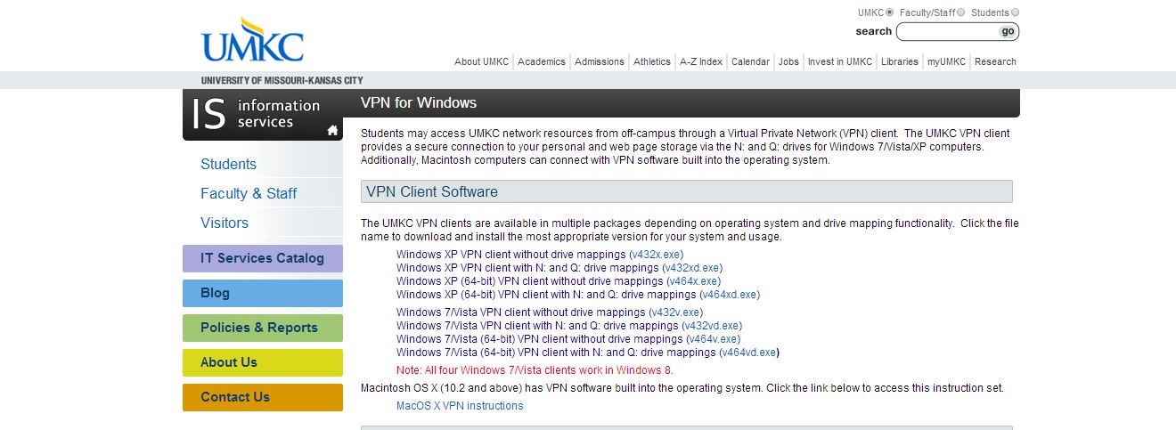

* Later I run the UMKC VPN and entered my SSO credentials. Then I was able to connect to the UMKC cloudera.

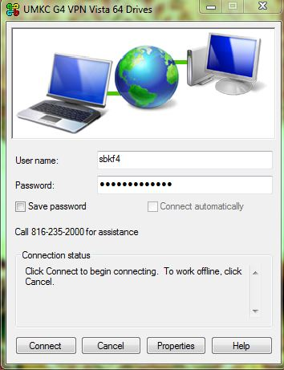.

* After clicking the connect button I get the command prompt and by entering our credentials again in the command prompt I will automatically connected to UMKC G4 VPN VISTA 64 DRIVES.

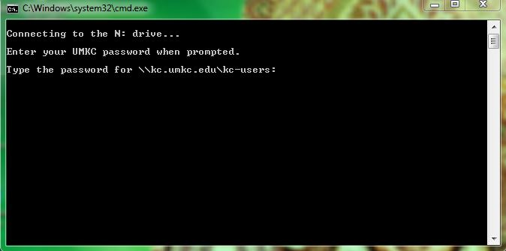

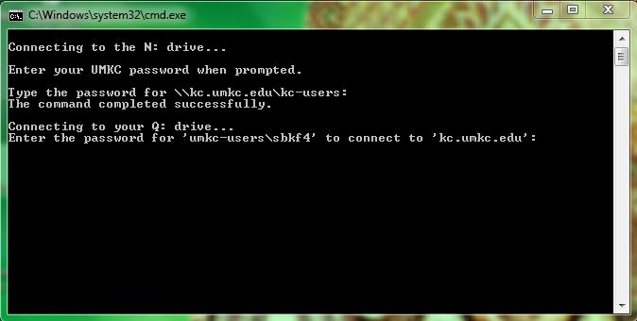

* In order to login to the cloudera manager I preferred <http://134.193.136.127:7180>

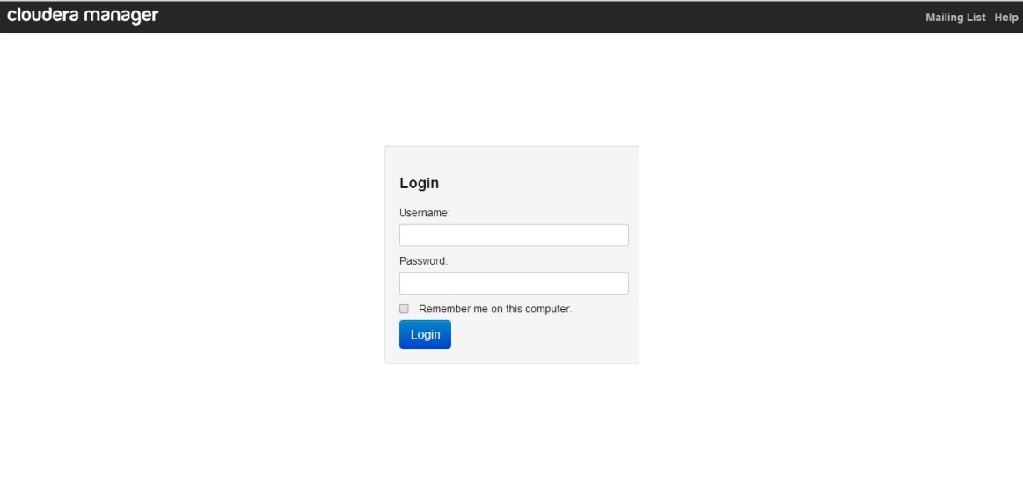

* After entering the username and password as “sbkf4” (i.e. my **SSO** credential) I can easily connect to the UMKC CLOUDERA MANAGER.

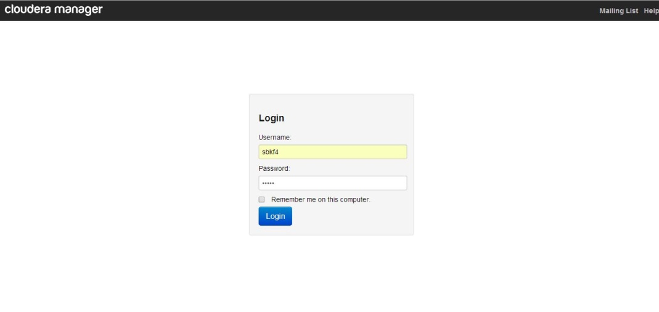

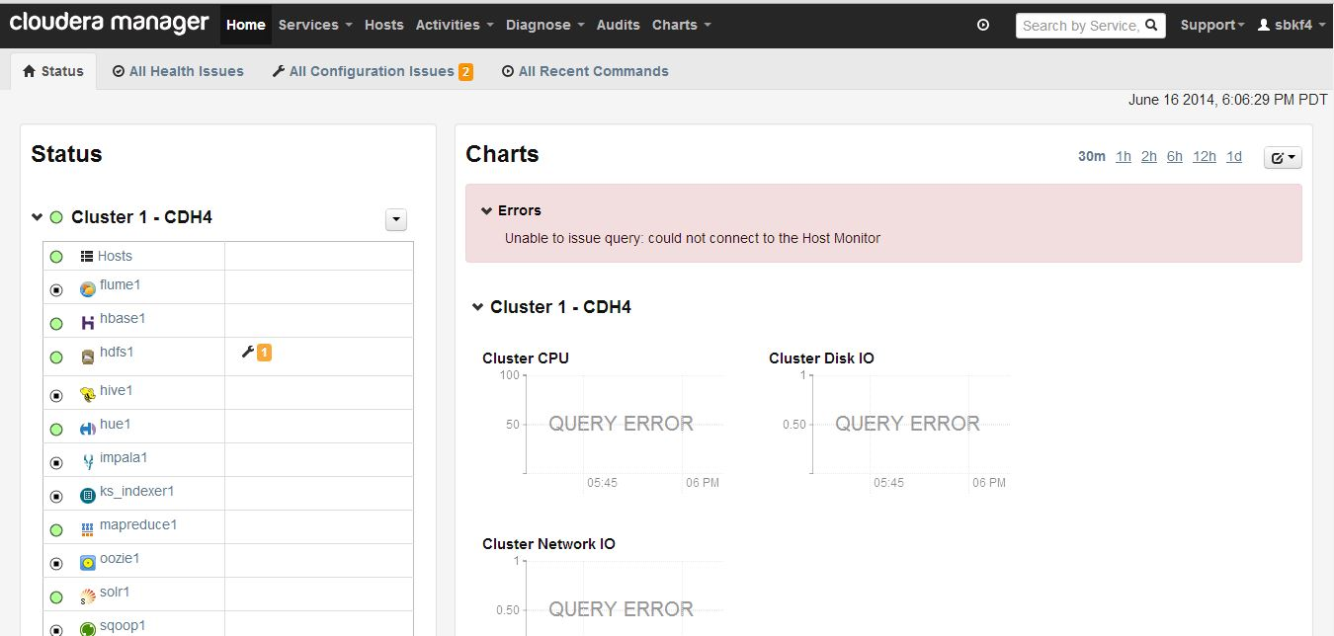

In this way I accessed UMKC Cloudera.

**SUBTASK 2: To install my own Cloudera Server:**

* In order to install Cloudera Server I have opted and downloaded VirtualBox one from the internet.

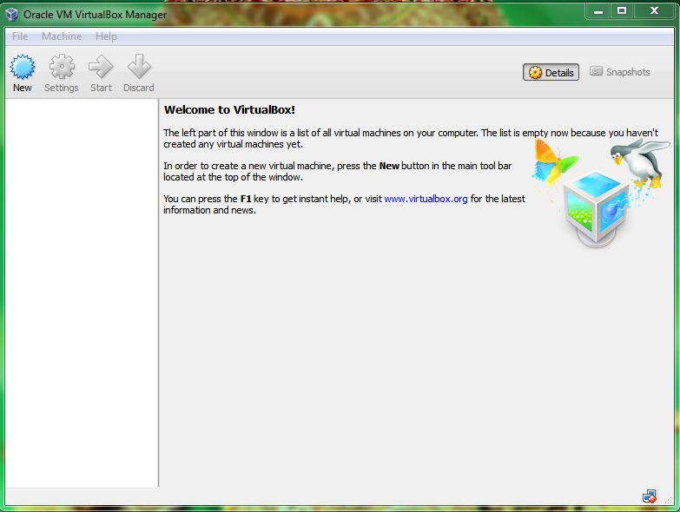

* Also I have downloaded VirtualBox image from the internet.

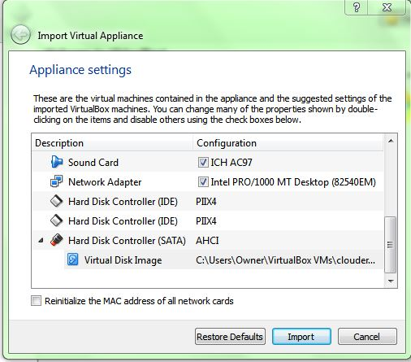

* By importing the Virtual Disk Image, the Cloudera Manager opens in Mozilla Firefox. After accepting the terms and conditions, a login page was displayed and I entered both the username and password as cloudera.



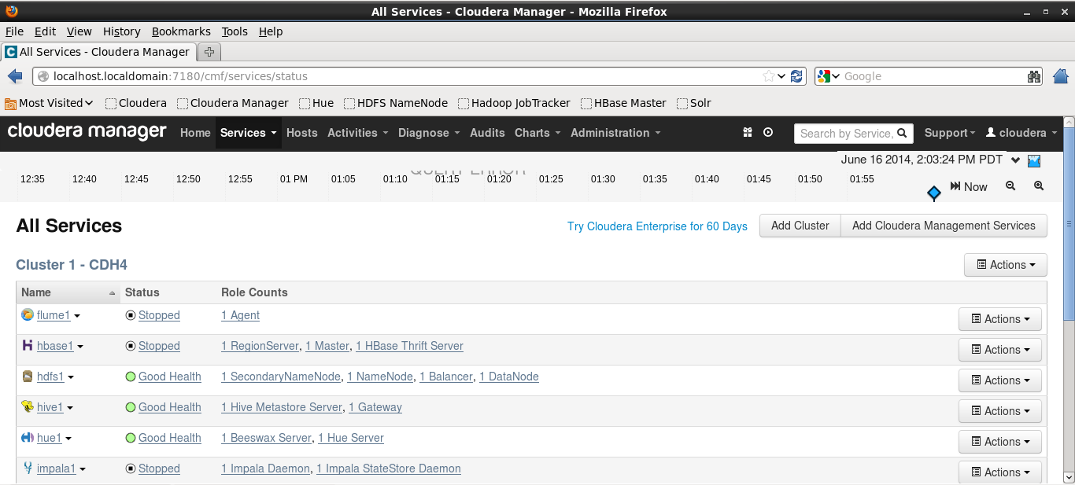

In this way I have installed my Cloudera Server.

**SUBTASK 3: To transfer files to Cloudera:**

* Firstly I downloaded WinSCP from the link that was given in the tutorial. WinSCP is used to transfer the files.

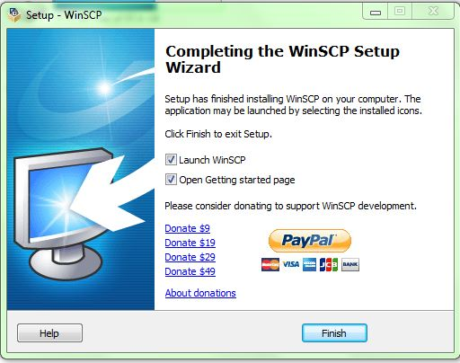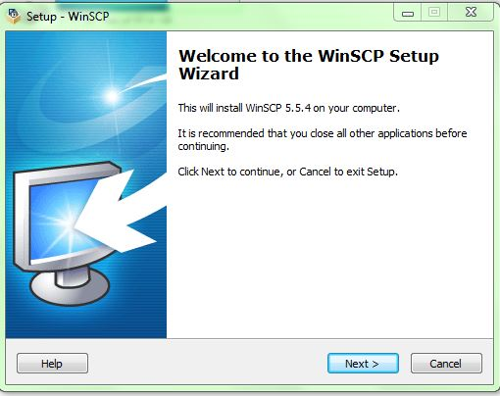

* Then in the WinSCP login page I entered the host name as 134.193.136.127, port number as 22 and entered both the username and password as “**group2**”.

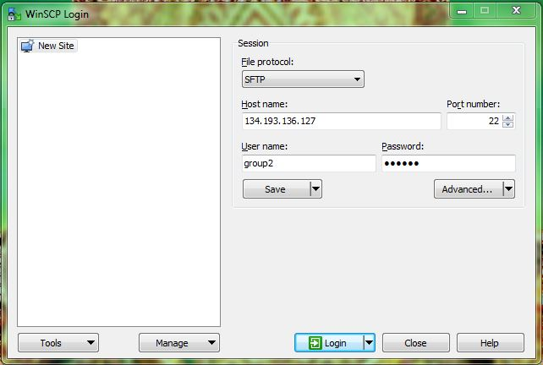

* After clicking the login button, it directly shows the page containing many files and there I can transfer my files to Cloudera.

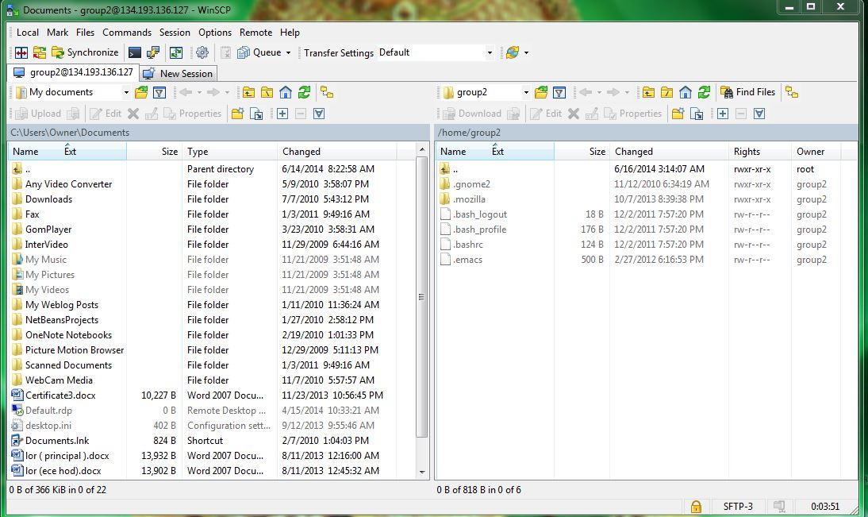

By doing this one can transfer files to Cloudera.

**SUBTASK 4: To run a program “Word Count” on cloudera:**

* At first I downloaded putty and run the .exe file. The command prompt window opens and asks for login and password. The login and password is **“group2”**.

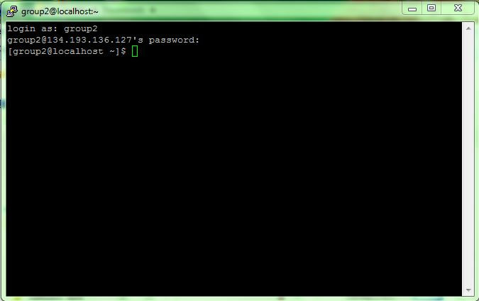

* I downloaded the Hadoop-WordCount by using the command: wget<http://salsahpc.indiana.edu/tutorial/source_code/Hadoop-WordCount.zip>.

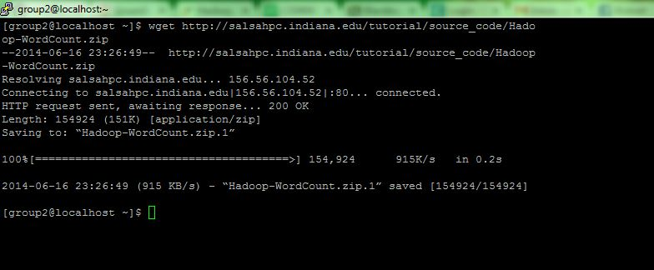

* Later I unzip the word count by entering the command: unzip Hadoop-WordCount.zip. Also I put the local input file to the hadoop input directory by using the command **“hadoop fs –ps input input1”**, and I run the wordcount.jar by using the command **“hadoop jar wordcount.jar word count input output67”.**

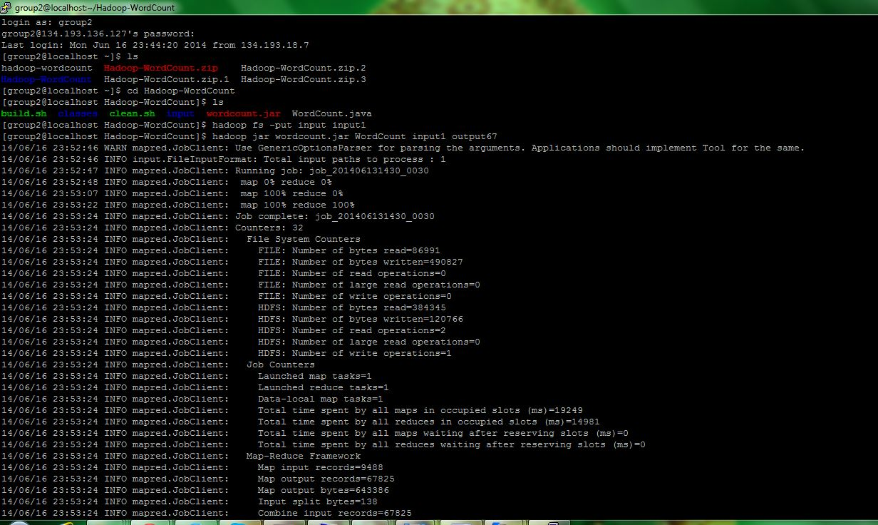

* In order to view the result/ output I entered the command hadoop **“fs –cat output67/*”.**

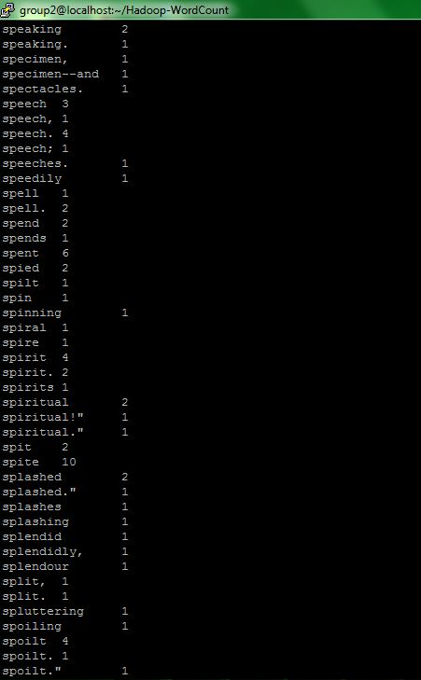

By doing all the downloads and running the commands using putty command prompt I was able to run the word count on Cloudera.

**TASK 3 – GITHUB & SCRUMDO:**

**SUBTASK 1: To create an account and deploy files to GitHub:**

* In order to create an account in GitHub I used the IP address given in the tutorial i.e. <https://github.com>

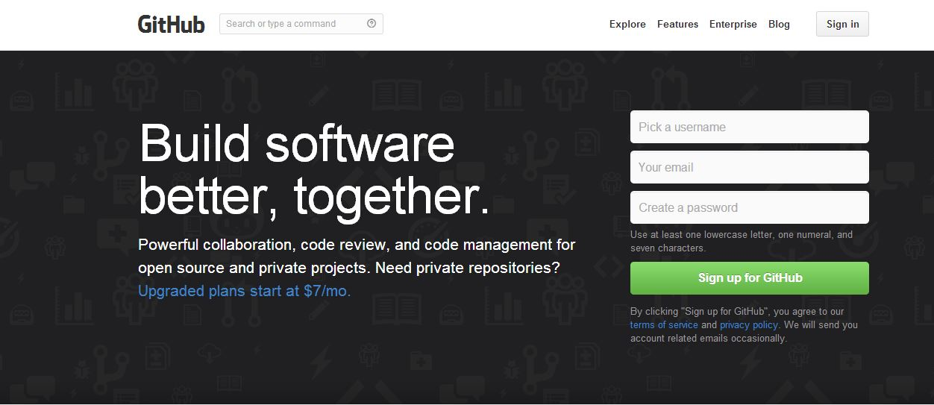

* After Sign up for GitHub, my account was created in GitHub.

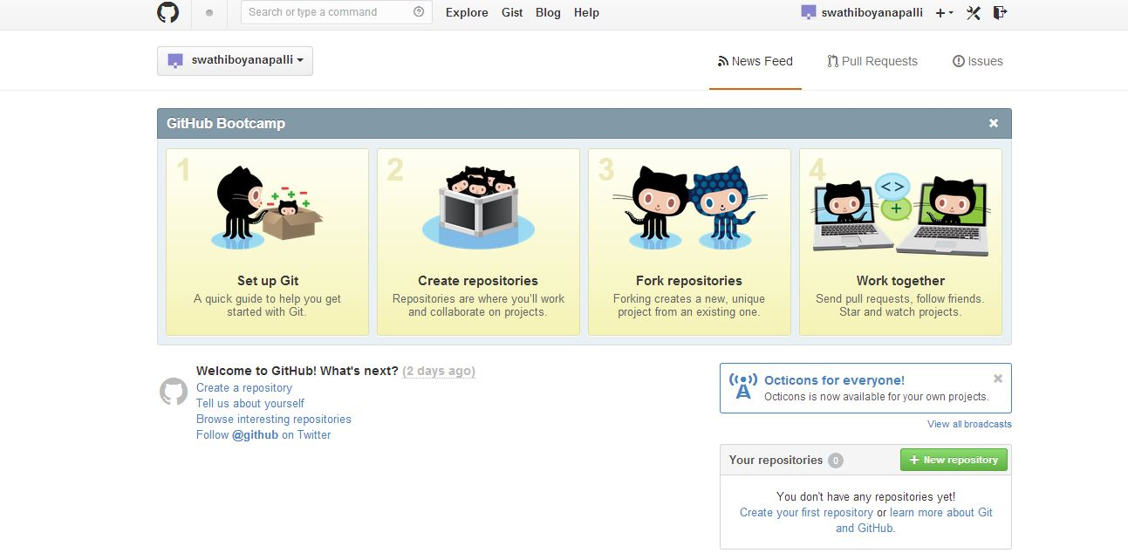

* I also installed GitHub for windows by downloading <http://windows.github.com/>. There also I created an account.

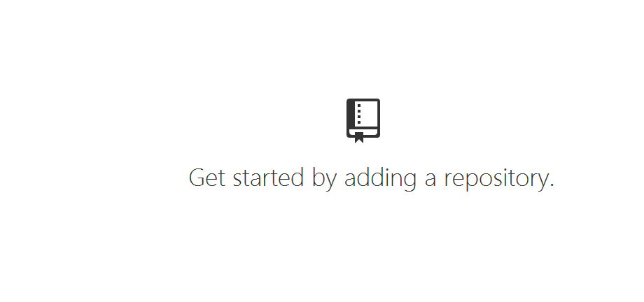

* Also I created organization, invited members and a new repository.

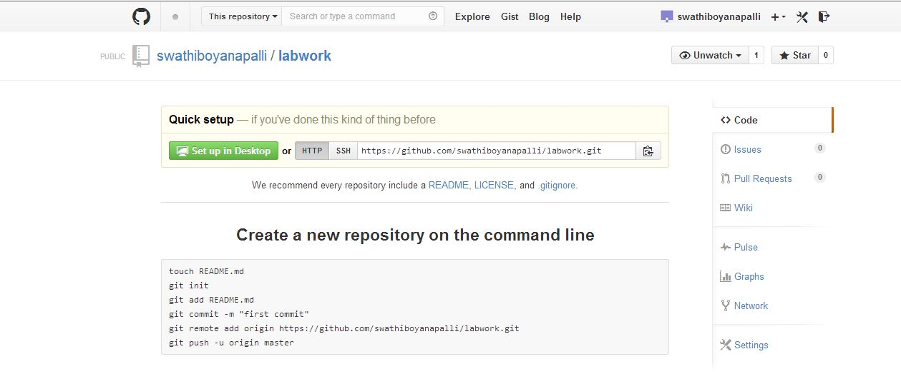

From here I can deploy my files to GitHub.

In this way I created Github and deployed my files to GitHub.

**SUBTASK 2: To create an account and design projects with Scrumdo:**

* At first I created an account by signing up in Scrumdo.

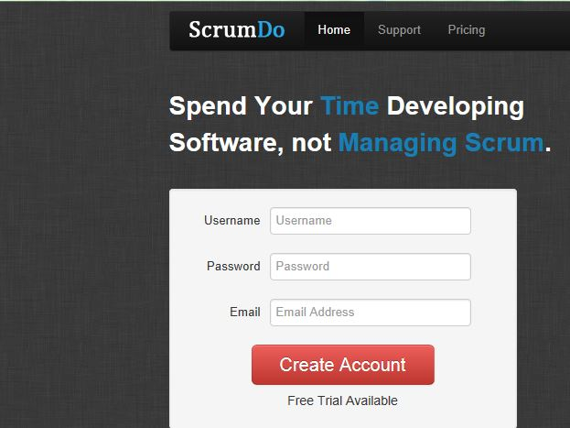

* There I created an organization and assigned subscription plan.

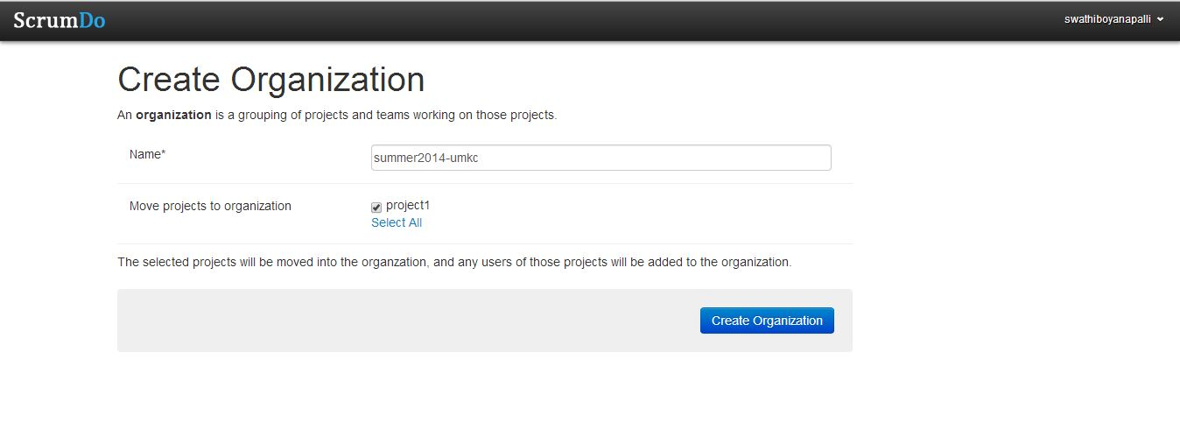

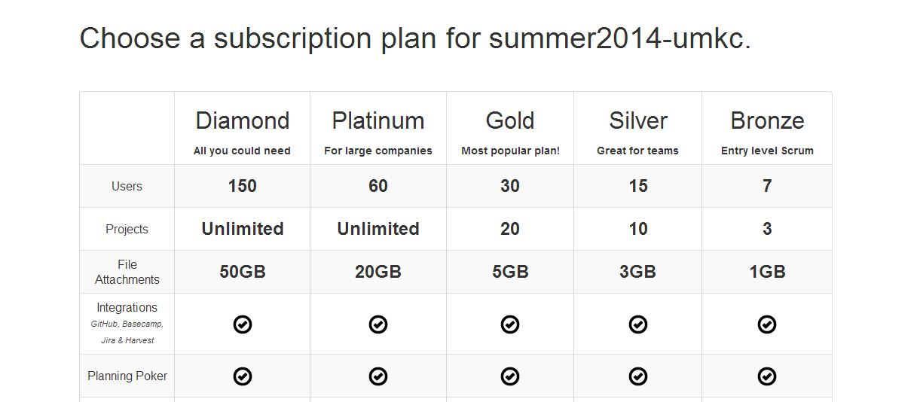

* Also I created a project where I can write a story, mention the details of the project, adding members to the project etc.

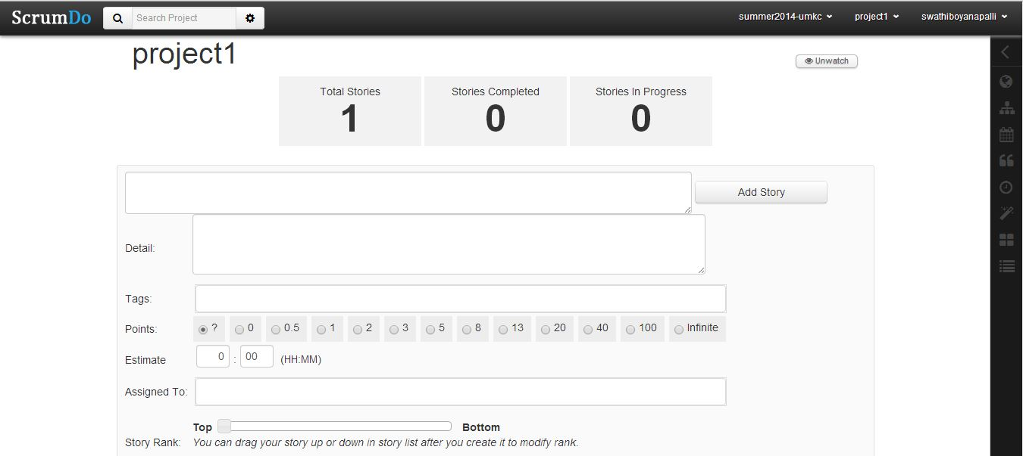

* I created iterations for a particular assigned project. In that iterations I assigned tasks that I have already done, doing, reviewing and to do.

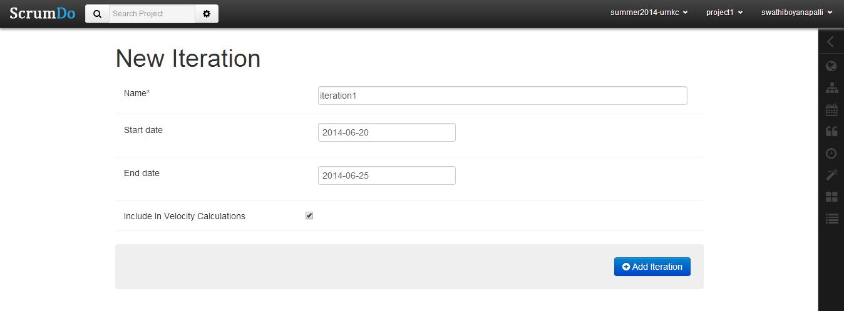

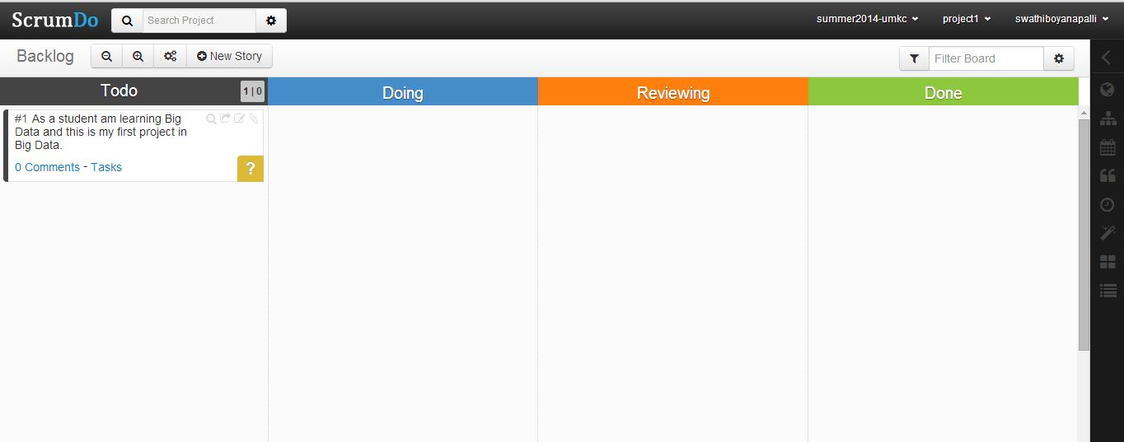

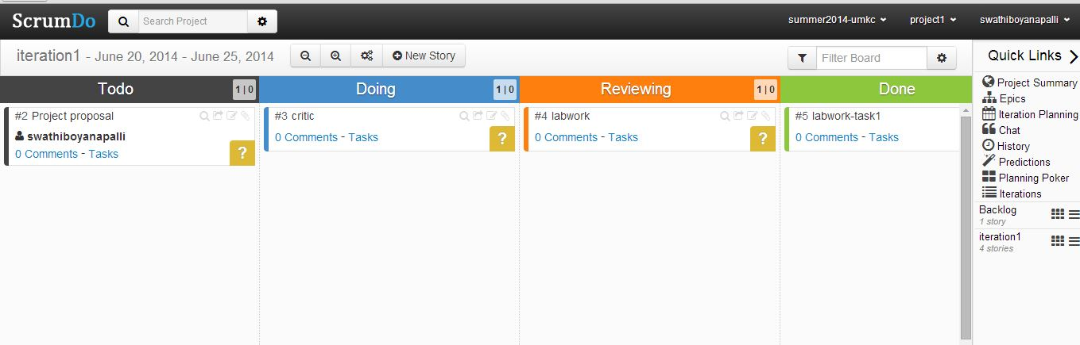

* Finally after creation of the project and iterations I added members to my project.

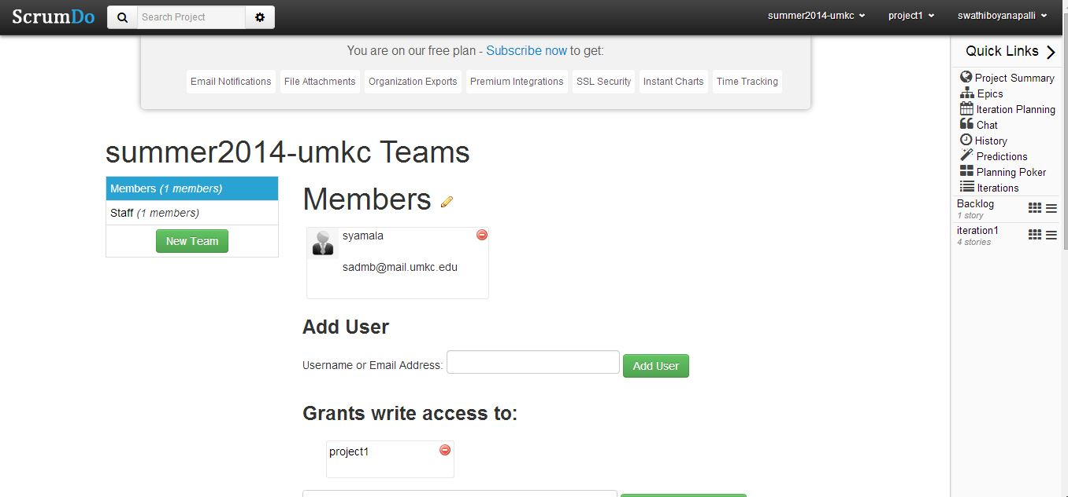

In this way I created an account in Scrumdo and also one project by using Scrumdo.